# TECHNICAL MATHEMATICS P1

# NOVEMBER 2024

# NATIONAL

# SENIOR CERTIFICATE



# GRADE 12

**MARKS: 150**

# TIME: 3 hours

**This question paper consists of 11 pages, a 2-page information sheet and 2 answer sheets.**

|  |  |  |
| --- | --- | --- |
| **INSTRUCTIONS AND INFORMATION** |  |  |

|  |  |  |
| --- | --- | --- |
| Read the following instructions carefully before answering the questions. |  |  |

|  |  |  |  |
| --- | --- | --- | --- |
| 1.  2.  3.  4.  5.  6.  7.  8.  9.  10.  11. | This question paper consists of NINE questions.  Answer ALL the questions.  Answer QUESTION 3.3.3 and QUESTION 4.1.5 on the ANSWER SHEETS provided. Write your centre number and examination number in the spaces provided on the ANSWER SHEETS and hand in the ANSWER SHEETS with your ANSWER BOOK.  Number the answers correctly according to the numbering system used in this question paper.  Clearly show ALL calculations, diagrams, graphs, etc. that you have used in determining your answers.  Answers only will NOT necessarily be awarded full marks.  You may use an approved scientific calculator (non-programmable and  non-graphical), unless stated otherwise.  If necessary, round off answers to TWO decimal places, unless stated otherwise.  Diagrams are NOT necessarily drawn to scale.  An information sheet with formulae is included at the end of the question paper.  Write neatly and legibly. |  |  |

|  |  |  |
| --- | --- | --- |
| **QUESTION 1** Nov |  |  |

|  |  |  |  |
| --- | --- | --- | --- |
| 1.1 | Solve for *x*: |  |  |

|  |  |  |  |  |
| --- | --- | --- | --- | --- |
|  | 1.1.1 |  |  | (2) |

|  |  |  |  |  |
| --- | --- | --- | --- | --- |
|  | 1.1.2 | (correct to TWO decimal places) |  | (4) |

|  |  |  |  |  |
| --- | --- | --- | --- | --- |
|  | 1.1.3 |  |  | (3) |

|  |  |  |  |
| --- | --- | --- | --- |
| 1.2 | Solve for *x*  and *y*  if: |  | (6) |

|  |  |  |  |
| --- | --- | --- | --- |
| 1.3 | The formula used to determine *CR* (compression ratio) when combustion and swept volumes are given is: |  |  |

|  |  |  |  |
| --- | --- | --- | --- |
|  | *CR*  Where:  *CR* = compression ratio  = combustion volume ()  *SV* = swept volume () |  |  |

|  |  |  |  |  |
| --- | --- | --- | --- | --- |
|  | 1.3.1 | Make  the subject of the formula. |  | (2) |

|  |  |  |  |  |
| --- | --- | --- | --- | --- |
|  | 1.3.2 | Hence, calculate the numerical value of *CV* if cm3 and the compression ratio is equal to. |  | (2) |

|  |  |  |  |
| --- | --- | --- | --- |
| 1.4 | Express  as a decimal number. |  | (1) |

|  |  |  |  |
| --- | --- | --- | --- |
| 1.5 | Evaluate  and leave your answer as a binary number. |  | (2)  **[22]** |
|  |  |  |  |

|  |  |  |
| --- | --- | --- |
| **QUESTION 2** |  |  |

|  |  |  |  |
| --- | --- | --- | --- |
| 2.1 | Given: . Determine the numerical value(s) of *p* if *x* is: |  |  |

|  |  |  |  |  |
| --- | --- | --- | --- | --- |
|  | 2.1.1 | Undefined |  | (1) |

|  |  |  |  |  |
| --- | --- | --- | --- | --- |
|  | 2.1.2 | Non-real |  | (2) |

|  |  |  |  |
| --- | --- | --- | --- |
| 2.2 | Determine the numerical value(s) of *t* for which the equation  will have real roots. |  | (4) |
|  |  |  | **[7]** |

|  |  |  |
| --- | --- | --- |
| **QUESTION 3** |  |  |

|  |  |  |  |
| --- | --- | --- | --- |
| 3.1 | Simplify the following, **showing ALL calculations**,where applicable: |  |  |

|  |  |  |  |  |
| --- | --- | --- | --- | --- |
|  | 3.1.1 |  |  | (1) |

|  |  |  |  |  |
| --- | --- | --- | --- | --- |
|  | 3.1.2 |  |  | (3) |

|  |  |  |  |  |
| --- | --- | --- | --- | --- |
|  | 3.1.3 |  |  | (1) |

|  |  |  |  |  |
| --- | --- | --- | --- | --- |
|  | 3.1.4 |  |  | (4) |

|  |  |  |  |
| --- | --- | --- | --- |
| 3.2 | Solve for *x*: |  | (3) |

|  |  |  |  |
| --- | --- | --- | --- |
| 3.3 | Given the complex number:  where |  |  |

|  |  |  |  |  |
| --- | --- | --- | --- | --- |
|  | 3.3.1 | Express  in the form . |  | (1) |

|  |  |  |  |  |
| --- | --- | --- | --- | --- |
|  | 3.3.2 | Write down  (conjugate of ). |  | (1) |

|  |  |  |  |  |
| --- | --- | --- | --- | --- |
|  | 3.3.3 | Represent  (conjugate of ) as an Argand diagram on the complex plane provided on the ANSWER SHEET. |  | (3) |

|  |  |  |  |  |  |
| --- | --- | --- | --- | --- | --- |
|  | 3.3.4 | Express  in the form , ( in degrees). |  | (5)  **[22]** | |
|  |  | |  | |  |

|  |  |  |
| --- | --- | --- |
| **QUESTION 4** |  |  |

|  |  |  |  |
| --- | --- | --- | --- |
| 4.1 | Given functions  *f* and *h* defined by  and |  |  |

|  |  |  |  |  |
| --- | --- | --- | --- | --- |
|  | 4.1.1 | Write down the equation of the asymptote of *f*. |  | (1) |

|  |  |  |  |  |
| --- | --- | --- | --- | --- |
|  | 4.1.2 | Write down the domain of *h*. |  | (2) |

|  |  |  |  |  |
| --- | --- | --- | --- | --- |
|  | 4.1.3 | Determine the *x*-intercept of *f*. |  | (2) |

|  |  |  |  |  |
| --- | --- | --- | --- | --- |
|  | 4.1.4 | Determine the *y*-intercept of *f*. |  | (2) |

|  |  |  |  |  |
| --- | --- | --- | --- | --- |
|  | 4.1.5 | Draw sketch graphs of *f* and *h* on the same set of axes provided on the ANSWER SHEET. Clearly indicate ALL the intercepts with the axes and the asymptote. |  | (5) |

|  |  |  |  |  |
| --- | --- | --- | --- | --- |
|  | 4.1.6 | Hence, use your graph to determine the values of *x* for which |  | (2) |

|  |  |  |  |
| --- | --- | --- | --- |
| 4.2 | The graph below represents function  *g* defined by  is the turning point of *g* and  is a point on *g*. |  |  |

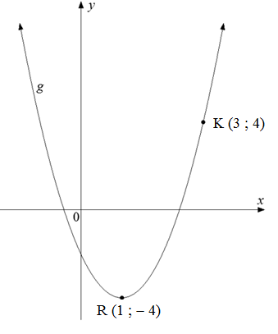

|  |  |  |  |
| --- | --- | --- | --- |
|  | Determine the equation of *g* in the form |  | (4) |

|  |  |  |  |
| --- | --- | --- | --- |
| 4.3 | The graphs below represent functions *h* and *p* defined by  and .   * is a point on *p* and B is the *x*-intercept of *h*. * The asymptote of *h*  passes through C, the *y*-intercept of *p*. * AB is perpendicular to the *x*-axis. |  |  |

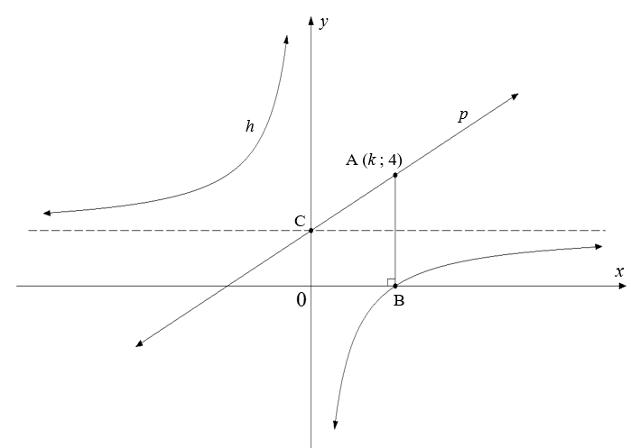

|  |  |  |  |  |
| --- | --- | --- | --- | --- |
|  | 4.3.1 | Write down the equations of the asymptotes of *h*. |  | (2) |

|  |  |  |  |  |
| --- | --- | --- | --- | --- |
|  | 4.3.2 | Determine the numerical value of *k*. |  | (2) |

|  |  |  |  |  |
| --- | --- | --- | --- | --- |
|  | 4.3.3 | Hence, write down the *x*-coordinate of B. |  | (1) |

|  |  |  |  |  |
| --- | --- | --- | --- | --- |
|  | 4.3.4 | Hence, determine the defining equation of *h*. |  | (2) |
|  |  |  |  | **[25]** |

|  |  |  |
| --- | --- | --- |
| **QUESTION 5** |  |  |

|  |  |  |  |
| --- | --- | --- | --- |
| 5.1 | The annual effective interest rate charged by a financial institution is 9,1%. Calculate the nominal interest rate charged per annum if it is compounded quarterly. |  | (4) |

|  |  |  |  |
| --- | --- | --- | --- |
| 5.2 | A town's population increased from 50 000 at a compound rate of 3% per annum over a five-year period. Determine the population of the town at the end of five years. |  | (3) |

|  |  |  |  |
| --- | --- | --- | --- |
| 5.3 | In 2018, engineering equipment costed R260 000. |  |  |

|  |  |  |  |  |
| --- | --- | --- | --- | --- |
|  | 5.3.1 | If the equipment bought in 2018 depreciated to 25% of its original value, calculate the current value of the equipment. |  | (1) |

|  |  |  |  |  |
| --- | --- | --- | --- | --- |
|  | 5.3.2 | The equipment depreciated at a rate of 14% per annum using the reducing-balance method. Determine how long (to the nearest year) it took for the equipment to depreciate to the value calculated in QUESTION 5.3.1. |  | (4) |

|  |  |  |  |
| --- | --- | --- | --- |
| 5.4 | An amount of R20 000 is invested into an account that offers an interest rate of 10% per annum, compounded monthly.     * At the end of 18 months, the interest rate changed to 8% per annum, compounded quarterly. * The interest rate then remained unchanged for the remaining years. * An amount of R3 000 was withdrawn from the account at the end of the  3rd year. |  |  |

|  |  |  |  |
| --- | --- | --- | --- |
|  | Determine the amount of money in the investment account at the end of the  4th year. |  | (5) |
|  |  |  | **[17]** |

|  |  |  |
| --- | --- | --- |
| **QUESTION 6** |  |  |

|  |  |  |  |
| --- | --- | --- | --- |
| 6.1 | Given:  Determine  using FIRST PRINCIPLES. |  | (5) |

|  |  |  |  |
| --- | --- | --- | --- |
| 6.2 | Determine if |  | (1) |

|  |  |  |  |
| --- | --- | --- | --- |
| 6.3 | Given: |  |  |

|  |  |  |  |  |
| --- | --- | --- | --- | --- |
|  | 6.3.1 | Simplify *y*. |  | (2) |

|  |  |  |  |  |
| --- | --- | --- | --- | --- |
|  | 6.3.2 | Hence, determine . |  | (2) |

|  |  |  |  |
| --- | --- | --- | --- |
| 6.4 | Given: |  |  |

|  |  |  |  |  |
| --- | --- | --- | --- | --- |
|  | 6.4.1 | Express  in exponential form. |  | (1) |

|  |  |  |  |  |
| --- | --- | --- | --- | --- |
|  | 6.4.2 | Hence, determine . |  | (2) |

|  |  |  |  |
| --- | --- | --- | --- |
| 6.5 | Given: |  |  |

|  |  |  |  |  |
| --- | --- | --- | --- | --- |
|  | 6.5.1 | Determine . |  | (2) |

|  |  |  |  |  |
| --- | --- | --- | --- | --- |
|  | 6.5.2 | Hence, determine the gradient of the tangent to *g* at |  | (2) |

|  |  |  |  |  |
| --- | --- | --- | --- | --- |
|  | 6.5.3 | Determine the coordinates of a point of contact of another tangent to the curve that has the same gradient as the tangent at |  | (4) |
|  |  | |  | **[21]** |

|  |  |  |
| --- | --- | --- |
| **QUESTION 7** |  |  |

|  |  |  |
| --- | --- | --- |
| The graph of function *f*, defined by , is drawn below.   * Points A, B and C are the *x*-intercepts and point D is the *y*-intercept of *f*. * E and F are the turning points of *f* and . |  |  |

|  |  |  |  |
| --- | --- | --- | --- |
| 7.1 | Write down the length of OD. |  | (1) |

|  |  |  |  |
| --- | --- | --- | --- |
| 7.2 | Determine the coordinates of points A and C. |  | (4) |

|  |  |  |  |
| --- | --- | --- | --- |
| 7.3 | Determine the coordinates of point G. |  | (6) |

|  |  |  |  |
| --- | --- | --- | --- |
| 7.4 | Use the graph to determine the values of *x* for which: |  |  |

|  |  |  |  |  |
| --- | --- | --- | --- | --- |
|  | 7.4.1 | if |  | (2) |

|  |  |  |  |  |
| --- | --- | --- | --- | --- |
|  | 7.4.2 | is decreasing |  | (2)  **[15]** |
|  |  | |  |  |

|  |  |  |
| --- | --- | --- |
| **QUESTION 8** |  |  |

|  |  |  |
| --- | --- | --- |
| A company manufactures *x*  bottle caps weekly and makes a profit of P rands. The relationship between the profit and the number of bottle caps produced weekly is given by the following formula: |  |  |

|  |  |  |
| --- | --- | --- |
| Determine: |  |  |

|  |  |  |  |
| --- | --- | --- | --- |
| 8.1 | The loss for the company if it is closed for a week |  | (1) |

|  |  |  |  |
| --- | --- | --- | --- |
| 8.2 |  |  | (1) |

|  |  |  |  |
| --- | --- | --- | --- |
| 8.3 | The maximum weekly profit that the company can make |  | (5) |
|  |  |  | **[7]** |

|  |  |  |
| --- | --- | --- |
| **QUESTION 9** |  |  |

|  |  |  |  |
| --- | --- | --- | --- |
| 9.1 | Determine the following integrals: |  |  |

|  |  |  |  |  |
| --- | --- | --- | --- | --- |
|  | 9.1.1 |  |  | (2) |

|  |  |  |  |  |
| --- | --- | --- | --- | --- |
|  | 9.1.2 |  |  | (4) |

|  |  |  |  |
| --- | --- | --- | --- |
| 9.2 | The sketch below shows function  *f*  defined by   * A represents the shaded area bounded by the graph of *f,* the *x*-axis and the ordinates  and * B represents the shaded area bounded by the graph of *f,* the *x*-axis and the ordinates  and |  |  |
|  | | | |

|  |  |  |  |  |
| --- | --- | --- | --- | --- |
|  | 9.2.1 | Determine: |  | (1) |

|  |  |  |  |  |
| --- | --- | --- | --- | --- |
|  | 9.2.2 | A learner claims that area B isequal to4 times that of area A.  Verify, showing ALL calculations, whether the learner's claim is VALID. |  | (7) |
|  | | |  | **[14]** |
|  | | |  |  |
| **TOTAL:** | | |  | **150** |

**INFORMATION SHEET: TECHNICAL MATHEMATICS**

   

, 

   





 , 

, 

 , 

M





InΔABC: 



  



Angular velocity  where *n* = rotation frequency

Angular velocity  where *n* = rotation frequency

Circumferential velocity where *D* = diameter and *n* = rotation frequency

Circumferential velocity  where = angular velocity and *r* = radius

Arc length  where *r* = radius and  = central angle in radians

Area of a sector  where *r* = radius, *s* = arc length

Area of a sector  where *r* = radius and  = central angle in radians

 where *h* = height of segment, *d* = diameter of circle   
 and *x* = length of chord

 where width of equal parts, 

 ordinate and *n* = number of ordinates

**OR**

 where width of equal parts,  ordinate

and *n* = number of ordinates

**ANSWER SHEET**

|  |  |  |  |  |  |  |  |  |  |  |
| --- | --- | --- | --- | --- | --- | --- | --- | --- | --- | --- |
| **CENTRE NUMBER** | | | |  |  |  |  |  |  |  |
|  |  |  |
| **EXAMINATION NUMBER** | | | |  |  |  |  |  |  |  |  |  |  |  |  |  |
|  |  |  |

**QUESTION 3.3.3**

Im

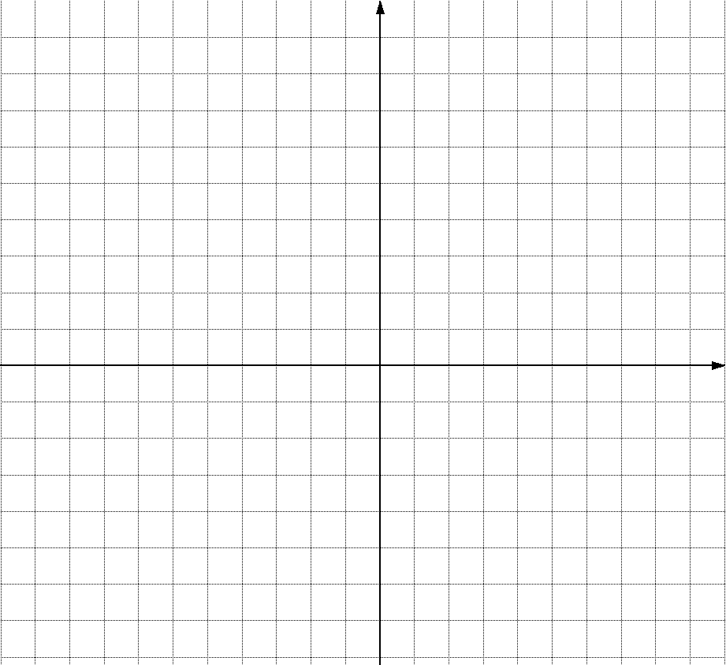

Re

0

**ANSWER SHEET**

|  |  |  |  |  |  |  |  |  |  |  |
| --- | --- | --- | --- | --- | --- | --- | --- | --- | --- | --- |
| **CENTRE NUMBER** | | | |  |  |  |  |  |  |  |
|  |  |  |
| **EXAMINATION NUMBER** | | | |  |  |  |  |  |  |  |  |  |  |  |  |  |
|  |  |  |

**QUESTION 4.1.5**

*y*



0

*x*